**DAILY ONLINE ACTIVITIES SUMMARY**

|  |  |  |  |  |  |  |  |  |
| --- | --- | --- | --- | --- | --- | --- | --- | --- |
| **Date:** | **30-05-2020** | | | | | **Name:** | **Raksha S** | |
| **Sem & Sec** | **6th B** | | | | | **USN:** | **4AL17CS073** | |
| **Online Test Summary** | | | | | | | | |
| **Subject** | | **Python** | | | | | | |
| **Max. Marks** | | **30** | | **Score** | | | **10** | |
| **Certification Course Summary** | | | | | | | | |
| **Course** | **FullStack Webdevelopment** | | | | | | | |
| **Certificate Provider** | | | **Greatlearning** | | **Duration** | | | **45days** |
| **Coding Challenges** | | | | | | | | |
| Problem Statement: 1. Write a c program to find the last remaining element in the array after reducing the array.  2. write jsp code to display today’s date and time using expression tag. | | | | | | | | |
| **Status:** YES, Completed all Programs | | | | | | | | |
| **Uploaded the report in Github** | | | | | **YES** | | | |
| **If yes Repository name** | | | | | <https://github.com/raksha05/Daily-Status>/Raksha-4AL17CS073/Raksha | | | |
| **Uploaded the report in slack** | | | | | **YES** | | | |

Online Test Details:

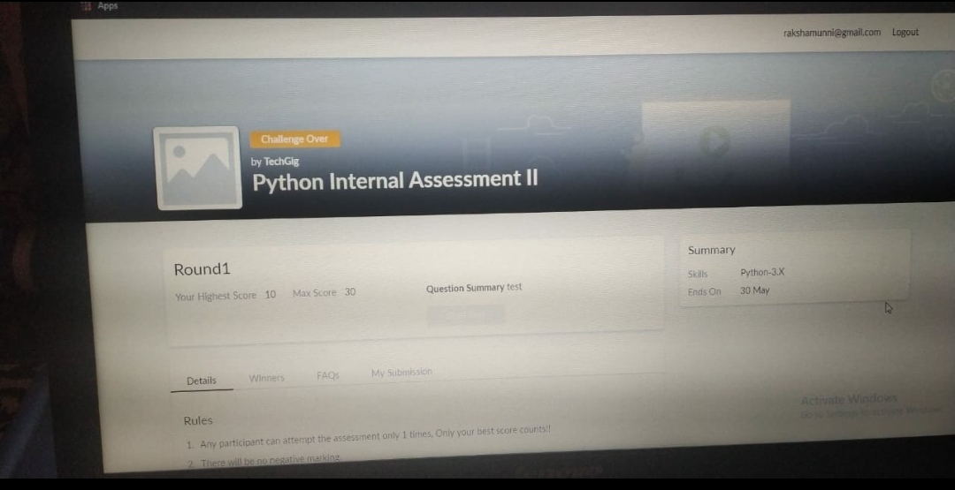

Scored 10 out of 30 in Python 2nd I.A test

Certification Course Details:

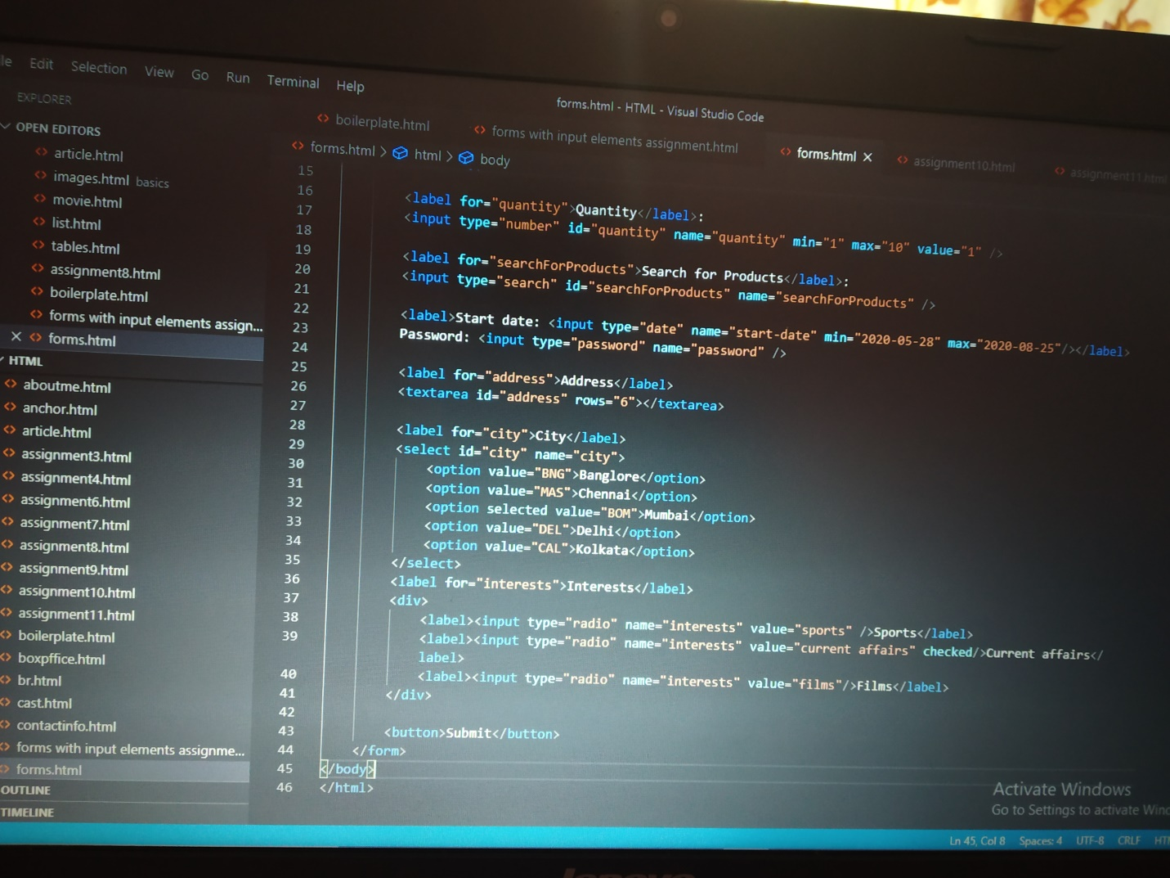

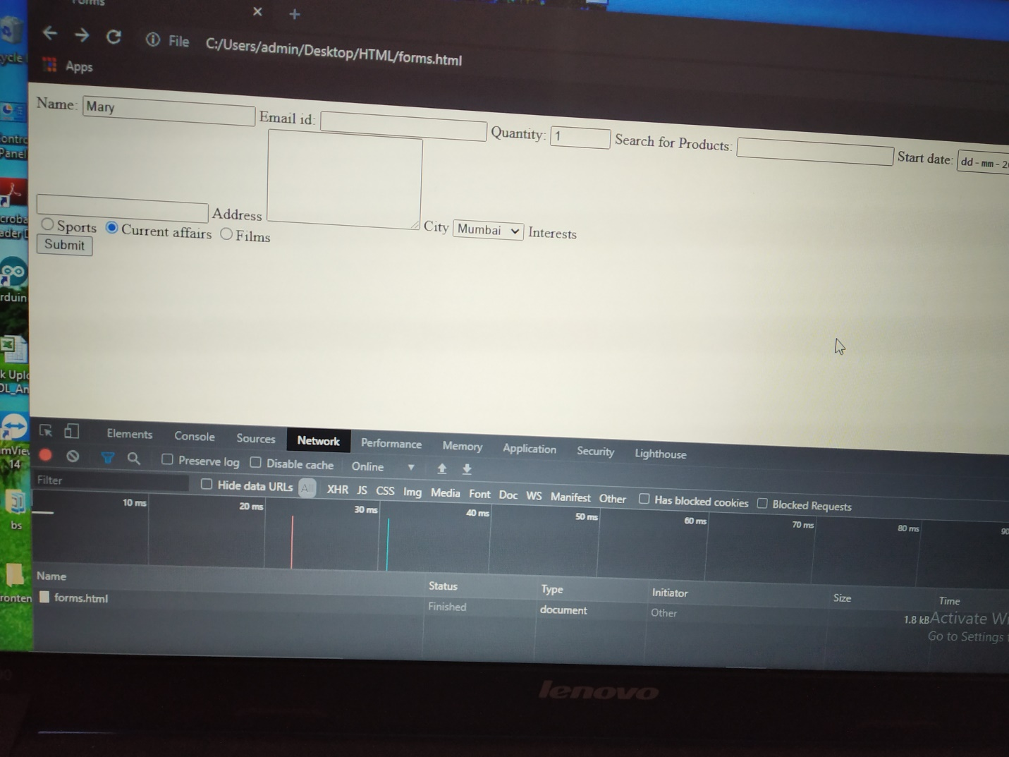

The above course is being taken up by me is based on FullStack Webdevelopment. Today in online course I studied about the butons,checkbox and its difference and where to apply checkbox and buttons.If there is multiple choices checkbox can be used but if its single choice then radio button can be used.

Coding Challenges Details:

Program1:

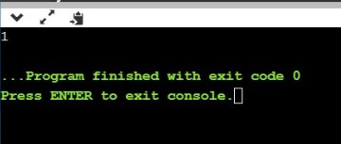

Program2:

